Tell your MP and local council representatives that you care about their climate action

I quote from the recently published, ‘The Climate Book’, created by Greta Thunberg:

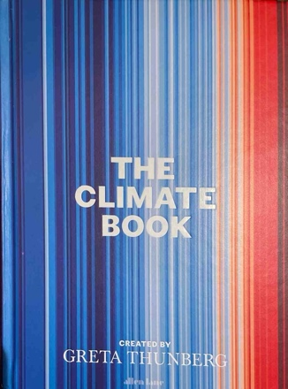
“When it comes to the climate and ecological crisis, we have solid unequivocal scientific evidence of the need for change. The problem is, all that evidence puts the current best available science on a collision course with our current economic system and with the way of life many people in the global North now consider their right…… Will we be able to use our schools, our knowledge and our technology (and church congregations?) to create a cultural shift that will make a change in time to avert a climate and environmental catastrophe? We are clearly capable of doing so. The question on whether we will, is entirely up to us.”

It is up to us as members of the electorate to convince our national and local politicians that climate action equals votes.

Over the last six months I have attended meetings of the the Future Oxfordshire Partnership which is a joint committee of the six councils of Oxfordshire together with key strategic partners working together to deliver ‘a better future for the county’. This is the steering group for coordinated action by our district and county councils. I have also attended a workshop to consider the future Local Enterprise Plan which is being developed by consultants, paid for by central government and constrained by central government desire for growth. The main policies focus is on GDP driven growth. The engine to promote this is building lots of market value houses in our countryside to house enterprising people.

This to this
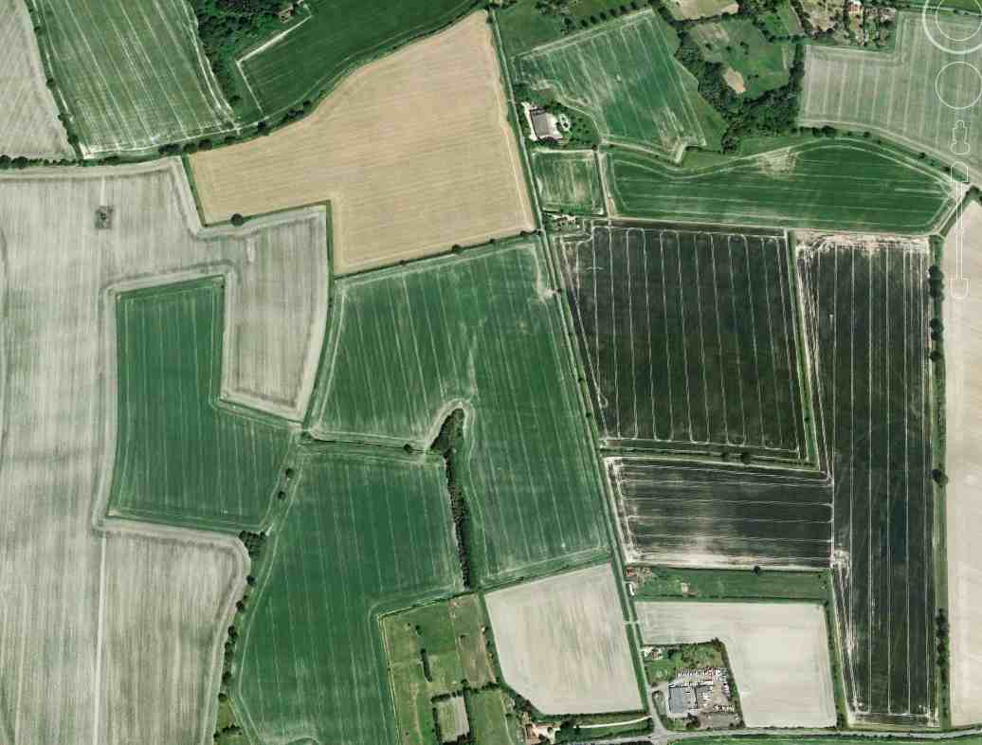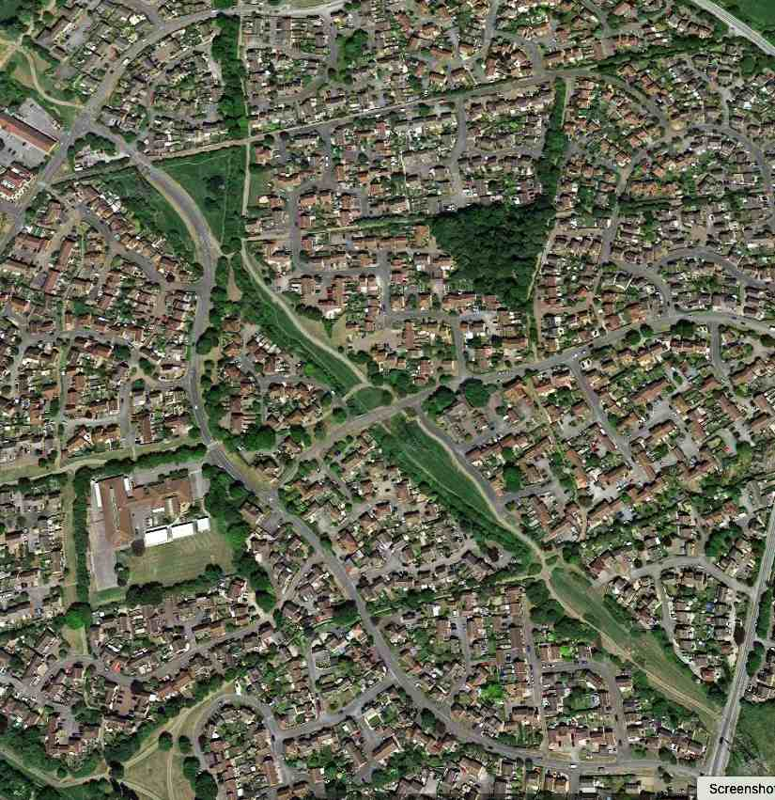

There is little emphasis on social housing and prices affordable for first time buyers.

Climate action is handled in a separate silo and is not being allowed to impact on the plans for growth. Either by mistake or intentionally, the hundreds of tons of carbon emission from the house and road building plans has been omitted from the County plan to reach net zero.

My first car was a vintage model and it had only one instrument on the dashboard that worked. That was the rev counter. Our economy is being driven with all the focus on GDP, the rev counter, without any regard to the economic equivalent of all the other instruments on the dashboard of a modern vehicle. Like my car, GDP dates from the 1930s.

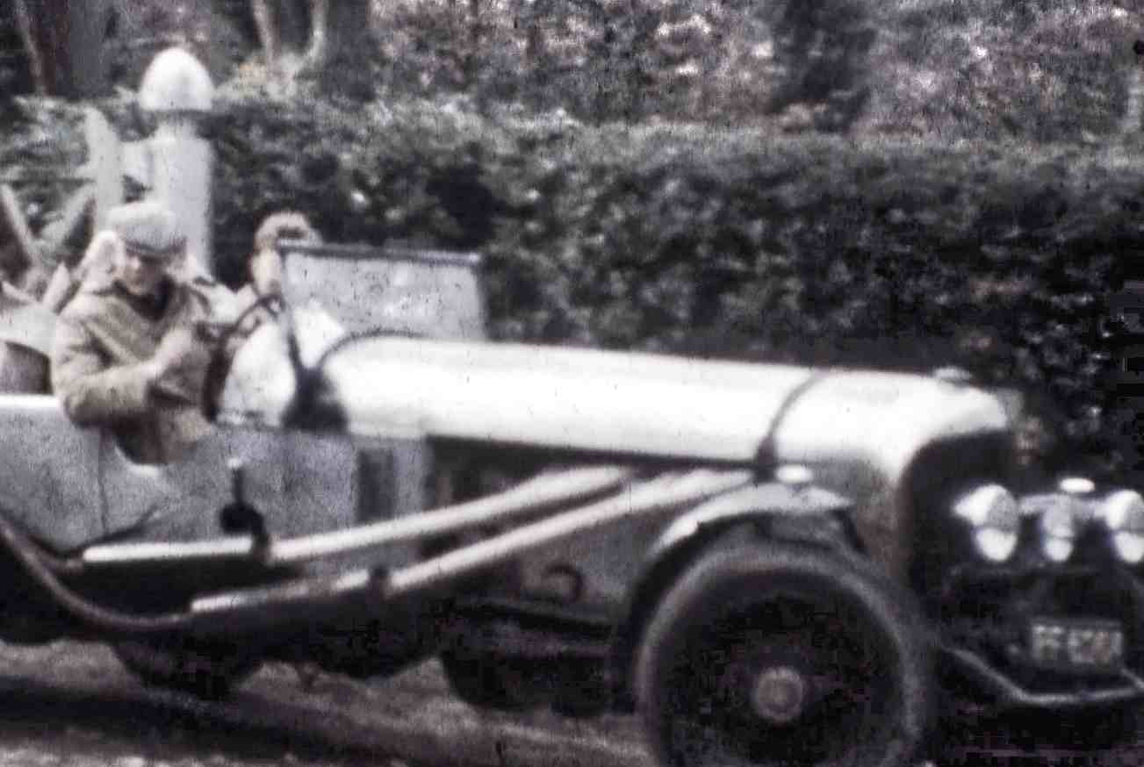

We must pay more attention to the well-being of future generations. Our economic dashboard should track the 12 social foundations and nine ecological ceilings as agreed by the UN. This is well addressed by Kate Rayworth’s ‘Doughnut’ economic model but our politicians seem frightened of this complexity.

It is up to us as members of the electorate to force our politicians to make the step change in thinking from economic prosperity in the immediate future to considering the well-being of future generations.

We will probably have to learn to live closer together. The map of world agricultural production in 2080 sends a strong message that more and more people are going to want to come and live in our Green and Pleasant land.

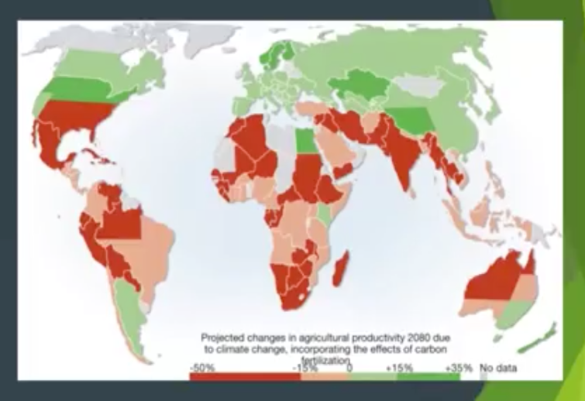

The charity ‘We Can Make‘ in Bristol is encouraging people to build campervan type garden sheds where they have space in their gardens in order to help house the homeless.
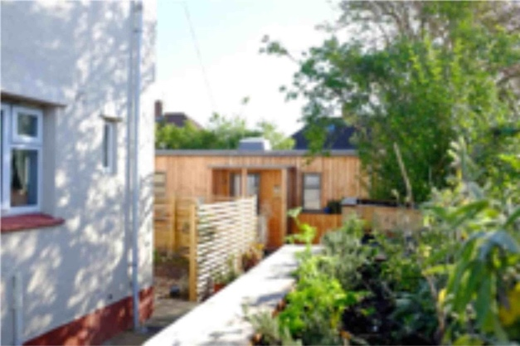

We may have to think even more radically. People pay lots of money to go and live close together in this sort of structure designed to provide everything the heart could desire, for instance a cruise liner. Building this sort of thing on land raises my argument to a level of absurdity, but perhaps humanity may have to become a bit absurd in order to survive in our changing world.

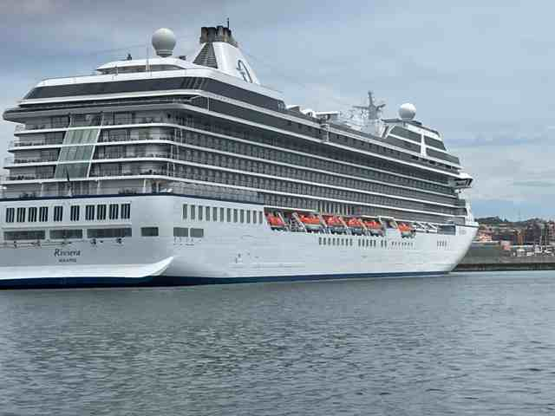

The problem is that the Ship of State Great Britain is about 45° off course. The ships radar shows very bad weather ahead; the long-range forecast is worse than we’ve ever seen in our lifetime, but if we change course now we can avoid the worst of it. Changing course is very difficult; the rudder is jammed amidships by legacy legislation, outdated economic principles and the consequent policies. The ships officers are focusing on a popularity contest and the captain has not yet given orders to free the steering. Some of the passengers are beginning to become aware of this situation but most are focused on the next two evenings fancy dress parties.

Please tell your MP and your local politicians that you care about the action they must take in order to address climate emergency and the well-being of our future generations. We have some material on the Bioabundance website. We suggest eleven possible topics but the top two are:

- The need is for Leadership from the top and across all Government Departments to guide the public in changing their behaviours;
- The Treasury must re-think the economics of GDP driven growth at any cost, so that the protection of our environment and the wellbeing of the population receive as much attention as policies to increase GDP.

Please make your representatives aware that their actions to address the climate emergency may affect the number of votes they will get at the next election!

George Curtis, The Churn Churches Climate Action Group,
17th June 2023
(Script for 17 July 2023 ‘Equipping Churches to Care for Creation’)

